* [Virtual Networking](https://googlecloud.qwiklabs.com/labs/410/instructions?focus_id=3290" \l "virtual-networking)
* [Cloud Virtual Networking](https://googlecloud.qwiklabs.com/labs/410/instructions?focus_id=3290#cloud-virtual-networking)
  + [**What you will do**](https://googlecloud.qwiklabs.com/labs/410/instructions?focus_id=3290#what-you-will-do)
  + [**What you will learn**](https://googlecloud.qwiklabs.com/labs/410/instructions?focus_id=3290#what-you-will-learn)
  + [**Part 1: Create the Network Topology**](https://googlecloud.qwiklabs.com/labs/410/instructions?focus_id=3290#part-1-create-the-network-topology)
  + [**Part 2: Create the VM Instances**](https://googlecloud.qwiklabs.com/labs/410/instructions?focus_id=3290#part-2-create-the-vm-instances)
  + [**Part 3: Work with Routes and Firewall Rules**](https://googlecloud.qwiklabs.com/labs/410/instructions?focus_id=3290#part-3-work-with-routes-and-firewall-rules)
* [Explore the default network](https://googlecloud.qwiklabs.com/labs/410/instructions?focus_id=3290#explore-the-default-network)
  + [**Step 1: Examine the networks in console**](https://googlecloud.qwiklabs.com/labs/410/instructions?focus_id=3290#step-1-examine-the-networks-in-console)
  + [**Step 2: Examine the routes**](https://googlecloud.qwiklabs.com/labs/410/instructions?focus_id=3290#step-2-examine-the-routes)
* [Create an auto-type network and subnetworks](https://googlecloud.qwiklabs.com/labs/410/instructions?focus_id=3290#create-an-auto-type-network-and-subnetworks)
  + [**Step 1: Create an auto-type network**](https://googlecloud.qwiklabs.com/labs/410/instructions?focus_id=3290#step-1-create-an-auto-type-network)
  + [**Step 2: Select the firewall rules**](https://googlecloud.qwiklabs.com/labs/410/instructions?focus_id=3290#step-2-select-the-firewall-rules)
  + [**Step 3: Create the network**](https://googlecloud.qwiklabs.com/labs/410/instructions?focus_id=3290#step-3-create-the-network)
* [Explore the auto-type network](https://googlecloud.qwiklabs.com/labs/410/instructions?focus_id=3290#explore-the-auto-type-network)
  + [**Step 1: Examine the routes**](https://googlecloud.qwiklabs.com/labs/410/instructions?focus_id=3290#step-1-examine-the-routes)
  + [**Step 2: Examine the firewall rules**](https://googlecloud.qwiklabs.com/labs/410/instructions?focus_id=3290#step-2-examine-the-firewall-rules)
* [Create a custom-type network](https://googlecloud.qwiklabs.com/labs/410/instructions?focus_id=3290#create-a-custom-type-network)
  + [**Step 1: Create a custom network**](https://googlecloud.qwiklabs.com/labs/410/instructions?focus_id=3290#step-1-create-a-custom-network)
  + [**Step 2: Specify the subnetworks**](https://googlecloud.qwiklabs.com/labs/410/instructions?focus_id=3290#step-2-specify-the-subnetworks)
  + [**Step 3: Examine the results: routes**](https://googlecloud.qwiklabs.com/labs/410/instructions?focus_id=3290#step-3-examine-the-results-routes)
  + [**Step 4: Examine the results: firewall rules**](https://googlecloud.qwiklabs.com/labs/410/instructions?focus_id=3290#step-4-examine-the-results-firewall-rules)
  + [**Step 5: Create default firewall rules for the learncustom network**](https://googlecloud.qwiklabs.com/labs/410/instructions?focus_id=3290#step-5-create-default-firewall-rules-for-the-learncustom-network)
* [Try to add an overlapping subnetwork](https://googlecloud.qwiklabs.com/labs/410/instructions?focus_id=3290#try-to-add-an-overlapping-subnetwork)
* [Create VM instances](https://googlecloud.qwiklabs.com/labs/410/instructions?focus_id=3290#create-vm-instances)
  + [**Step 1: Create the learn-1 VM**](https://googlecloud.qwiklabs.com/labs/410/instructions?focus_id=3290#step-1-create-the-learn-1-vm)
  + [**Step 2: Create the learn-2 VM**](https://googlecloud.qwiklabs.com/labs/410/instructions?focus_id=3290#step-2-create-the-learn-2-vm)
  + [**Step 3: Create the learn-3 VM**](https://googlecloud.qwiklabs.com/labs/410/instructions?focus_id=3290#step-3-create-the-learn-3-vm)
  + [**Step 4: Create the learn-4 VM**](https://googlecloud.qwiklabs.com/labs/410/instructions?focus_id=3290#step-4-create-the-learn-4-vm)
  + [**Step 5: Create the learn-5 VM**](https://googlecloud.qwiklabs.com/labs/410/instructions?focus_id=3290#step-5-create-the-learn-5-vm)
  + [**Step 6: Verify that all the test VMs are running**](https://googlecloud.qwiklabs.com/labs/410/instructions?focus_id=3290#step-6-verify-that-all-the-test-vms-are-running)
* [Explore connectivity](https://googlecloud.qwiklabs.com/labs/410/instructions?focus_id=3290#explore-connectivity)
  + [**Step 1: ping from learn-1**](https://googlecloud.qwiklabs.com/labs/410/instructions?focus_id=3290#step-1-ping-from-learn-1)
  + [**Step 2: traceroute from learn-1**](https://googlecloud.qwiklabs.com/labs/410/instructions?focus_id=3290#step-2-traceroute-from-learn-1)
  + [**Step 3: ping to learn-3**](https://googlecloud.qwiklabs.com/labs/410/instructions?focus_id=3290#step-3-ping-to-learn-3)
* [Edit the firewall rule](https://googlecloud.qwiklabs.com/labs/410/instructions?focus_id=3290#edit-the-firewall-rule)
  + [**Step 1: ping to the other VMs**](https://googlecloud.qwiklabs.com/labs/410/instructions?focus_id=3290#step-1-ping-to-the-other-vms)
  + [**Step 2: Edit the firewall rule**](https://googlecloud.qwiklabs.com/labs/410/instructions?focus_id=3290#step-2-edit-the-firewall-rule)
  + [**Step 3: Try again**](https://googlecloud.qwiklabs.com/labs/410/instructions?focus_id=3290#step-3-try-again)
* [Convert an auto-type network to a custom -type network](https://googlecloud.qwiklabs.com/labs/410/instructions?focus_id=3290#convert-an-auto-type-network-to-a-custom-type-network)
  + [**Step 1: Convert the network mode**](https://googlecloud.qwiklabs.com/labs/410/instructions?focus_id=3290#step-1-convert-the-network-mode)
  + [**Step 2: Delete the subnetwork**](https://googlecloud.qwiklabs.com/labs/410/instructions?focus_id=3290#step-2-delete-the-subnetwork)
  + [**Step 3: Create the new subnetwork**](https://googlecloud.qwiklabs.com/labs/410/instructions?focus_id=3290#step-3-create-the-new-subnetwork)
* [Expand a subnetwork](https://googlecloud.qwiklabs.com/labs/410/instructions?focus_id=3290#expand-a-subnetwork)
  + [**Step 1: Prepare to modify the address range**](https://googlecloud.qwiklabs.com/labs/410/instructions?focus_id=3290#step-1-prepare-to-modify-the-address-range)
  + [**Step 2: Increase the address range**](https://googlecloud.qwiklabs.com/labs/410/instructions?focus_id=3290#step-2-increase-the-address-range)
  + [**Step 3: Verify the change**](https://googlecloud.qwiklabs.com/labs/410/instructions?focus_id=3290#step-3-verify-the-change)
* [Delete resources that are no longer needed](https://googlecloud.qwiklabs.com/labs/410/instructions?focus_id=3290#delete-resources-that-are-no-longer-needed)
  + [**Step 1: Delete the VMs**](https://googlecloud.qwiklabs.com/labs/410/instructions?focus_id=3290#step-1-delete-the-vms)
  + [**Step 2: Delete the firewall rules you created**](https://googlecloud.qwiklabs.com/labs/410/instructions?focus_id=3290#step-2-delete-the-firewall-rules-you-created)
  + [**Step 3: Networks**](https://googlecloud.qwiklabs.com/labs/410/instructions?focus_id=3290#step-3-networks)
  + [**Step 4: Review the delete project procedure**](https://googlecloud.qwiklabs.com/labs/410/instructions?focus_id=3290#step-4-review-the-delete-project-procedure)
* [Review](https://googlecloud.qwiklabs.com/labs/410/instructions?focus_id=3290#review)

**VIRTUAL NETWORKING**

**Cloud Virtual Networking**

**What you will do**

* Create a default-type network, an auto-type network and a custom-type network and associated subnetworks
* Compare connectivity in the various types of networks
* Create routes and firewall rules using IP address and Tags to enable connectivity
* Convert an auto-type network to a custom-type network
* Expand the range of a subnetwork to allow for growth
* Create, expand, and delete subnetworks

**What you will learn**

* The relationships between networks and subnetworks
* The types of networks and how they differ
* How to use routes to establish paths for communications
* How to use firewall rules to restrict communications
* How to expand the range of a subnetwork
* How to convert an auto-type network to a custom-type network

Here is a preview of the lab activities, and the networks you will create.

**Part 1: Create the Network Topology**

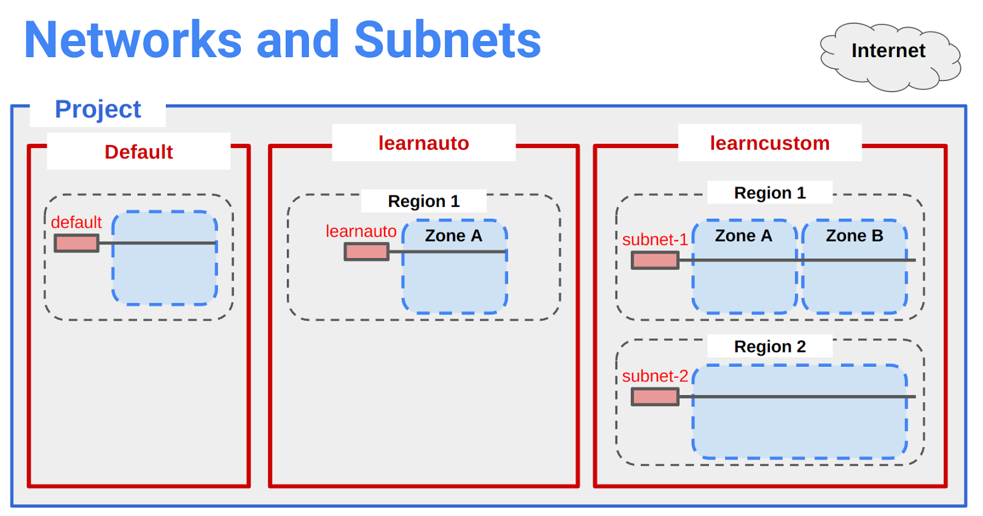

**Part 2: Create the VM Instances**

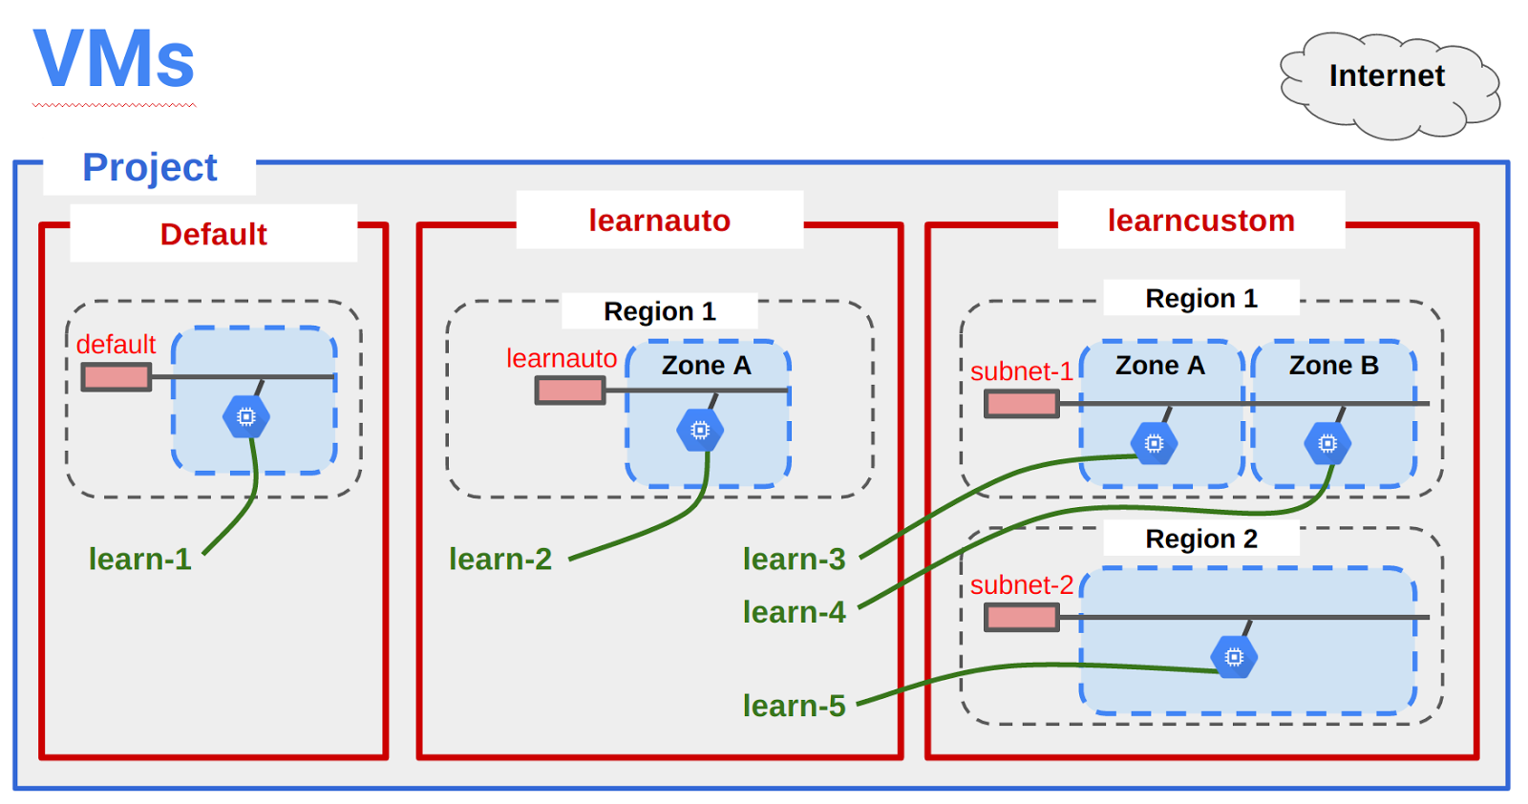

**Part 3: Work with Routes and Firewall Rules**

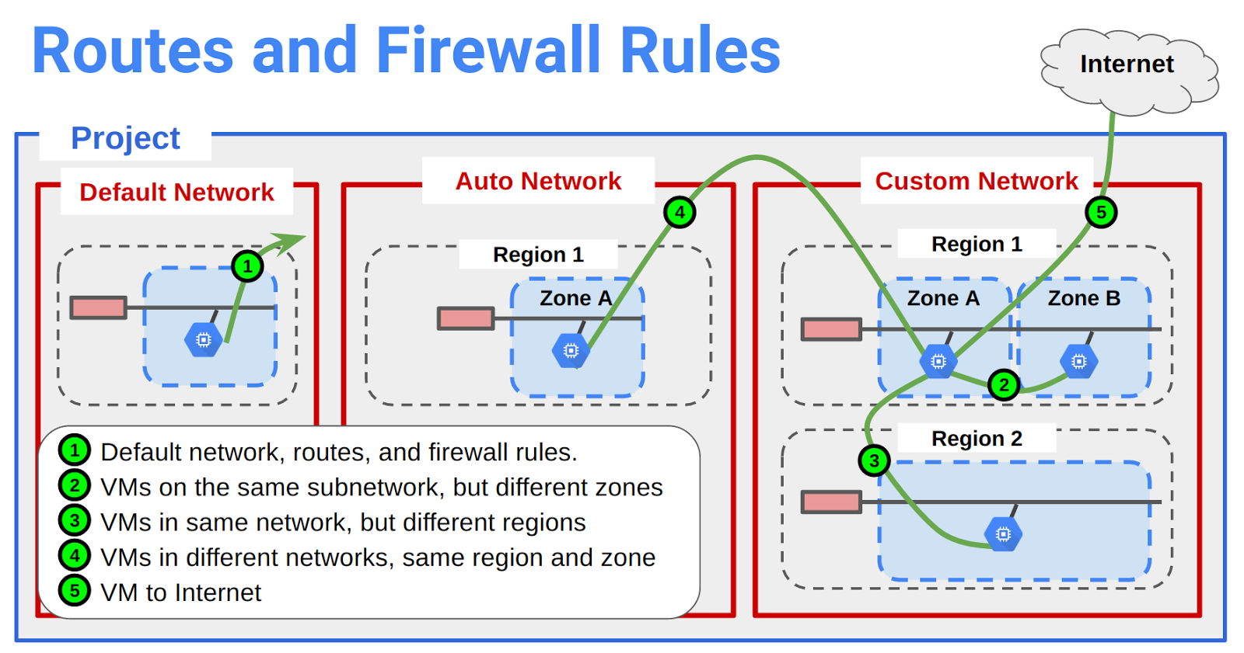

The scoping and connectivity relationships between zones, regions, networks, and subnets are different from networking in other public clouds.

You have been provided with a Project in Qwiklabs. The project ID is a unique name across all Google Cloud projects. It will be referred to later in this lab as .

Note: In most labs in this class you choose any region and any zone for the purposes of the lab. In this lab you will be given specific regions and zones because you will be constructing and exploring very specific networking relationships.

**Explore the default network**

The default network is created automatically for you with each new project. The default network layout is not ideal for managing resources. It's main benefit is that it is a fast way to get a project setup and running. It's great for prototyping solutions and for training purposes.

**Step 1: Examine the networks in console**

Console: **Products and Services > Networking > Networks**

Notice the Default Network. It has been created automatically for you with a Subnetwork in each Region.

Example:



How many Internal IP addresses are available for VMs in each subnetwork?

1. CIDR /20 = 4096 address
2. All 1's address is used for broadcast
3. All 0's address represents the subnetwork
4. First address in the range the '.1' address, belongs to the virtual router / virtual firewall (labeled gateway).
5. Therefore, each subnetwork can address 4093 VMs

**Step 2: Examine the routes**

Console: **Products and Services > Networking > Routes**

Notice that a route has been created for each subnetwork, and one global route to enable traffic to the Internet.

**Create an auto-type network and subnetworks**

**Step 1: Create an auto-type network**

Console: **Products and Services > Networking > Networks**

Click on **[+ Create Network]**.

|  |  |
| --- | --- |
| **Property** | **Value** |
| **Name**: | learnauto |
| **Description:** | Learn about auto-type networks |
| **Subnetworks** | Click on the [Automatic] tab |

When you click on Automatic, you should see it automatically populate the list of subnetworks to be created.

**Step 2: Select the firewall rules**

**Select all of the firewall rules listed**. If they are not selected they won't be created.

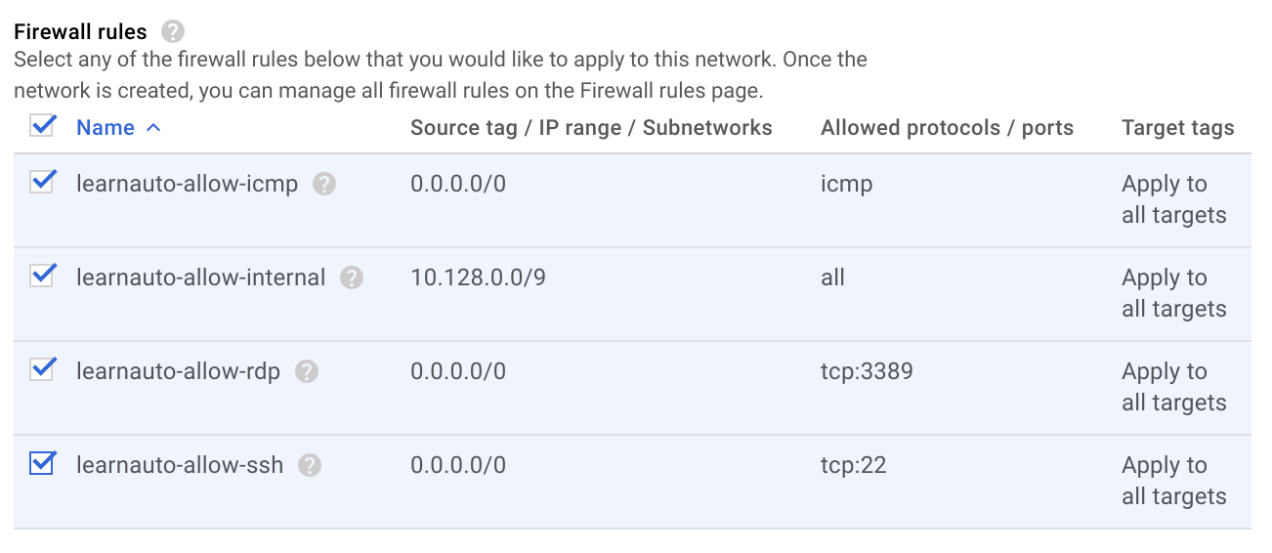

**Step 3: Create the network**

1. At the bottom of the dialog are two links labeled "Equivalent REST or command line".
2. Click on the **REST** link to see POST commands for API programming automation of this process.
3. Click CLOSE
4. Click on the **command line** link to see commands you could use for automation of this process.
5. You *could* use these commands to create the network by clicking [Run in Cloud Shell] -- *but don't do it. *

Note: These commands tend to include options that are not required. They may not work in a bash script without being altered. Don't rely on them. You should consider these more of a suggestion. If you need to automate with scripts, plan to craft your own commands from examples in the documentation.

1. Click CLOSE
2. Click on the **[CREATE] button.**

Click on the REFRESH button occasionally until the networks are created and appear in the list.

**EXPLORE THE AUTO-TYPE NETWORK**

**Step 1: Examine the routes**

Console: **Products and Services > Networking > Routes**

Notice that a route has been created for each subnetwork, and one global route was created to enable traffic from anywhere, including the Internet.

Click on the title Destination IP ranges to sort the list of routes.

Notice that there is an identical subnetwork and route in the learnauto network as there is in the Default network. It is possible to have VMs with duplicate Internal IP addresses in the two networks.

**Step 2: Examine the firewall rules**

Console: **Products and Services > Networking > Firewall rules**

Verify that firewall rules were created for the learnauto network and its subnetworks.

If you deleted your Default network, you could always recreate it as an auto network using the name "Default".

**Create a custom-type network**

You will be creating a custom-type network named . It will have three subnetworks (subnet-1a) 192.168.5.0/24, (subnet-1b) 192.168.3.0/24, in the same region, and (subnet-2) 192.168.7.0/24 in a different region.

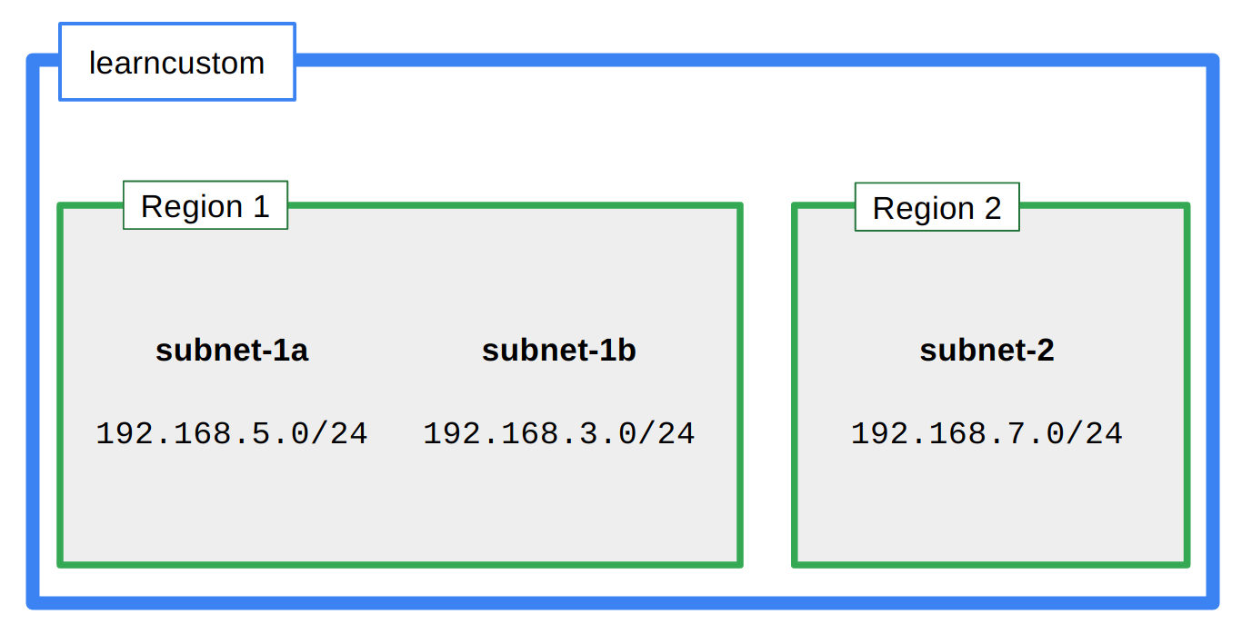

**Step 1: Create a custom network**

Console: **Products and Services > Networking > Networks**

Click on **[+ Create Network]**.

|  |  |
| --- | --- |
| **Property** | **Value** |
| **Name**: | learncustom |
| **Description:** | Learn about custom networks |
| **Subnetworks** | Click on the [Custom] tab |

**Step 2: Specify the subnetworks**

Use the dialog to add three subnetworks as follows.

Click [+ Add subnetwork] to add another.

First subnetwork:

|  |  |
| --- | --- |
| **Property** | **Value** |
| **Name**: | subnet-1a |
| **Region:** | us-east1 |
| **IP address range:** | 192.168.5.0/24 |

Second subnetwork:

|  |  |
| --- | --- |
| **Property** | **Value** |
| **Name**: | subnet-1b |
| **Region:** | us-east1 |
| **IP address range:** | 192.168.3.0/24 |

Third subnetwork:

|  |  |
| --- | --- |
| **Property** | **Value** |
| **Name**: | subnet-2 |
| **Region:** | us-west1 |
| **IP address range:** | 192.168.7.0/24 |

It should look something like this:

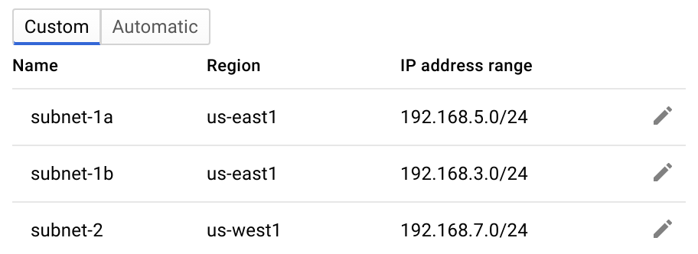

Click the [Create] button.

**Step 3: Examine the results: routes**

Did creating the custom network automatically create routes?

Console: **Products and Services > Networking > Routes**

You can click on **Network** in the table header to sort by Network name. You should see routes created for each subnetwork.

**Step 4: Examine the results: firewall rules**

Did creating the custom network automatically create firewall rules?

Console: **Products and Services > Networking > Firewall rules**

You can click on **Network** in the table header to sort by Network name.

No default firewall rules were created for the custom network. You will have to manually add default rules in during the next step.

**Step 5: Create default firewall rules for the learncustom network**

Notice that for the other networks, the  network and the  network, that GCP automatically created default firewall rules allowing SSH traffic (tcp:22), icmp traffic, and rdp (tcp:3389) traffic for Windows VMs.

Add a firewall rule to provide the same access for the  network.

Console: **Products and Services > Networking > Firewall rules**

Click on **[+ Create Firewall Rule]**

|  |  |
| --- | --- |
| **Property** | **Value** |
| **Name**: | allow-ssh-icmp-rdp-learncustom |
| **Network:** | learncustom |
| **Source filter:** | Allow from any source (0.0.0.0) |
| **Allowed protocols and ports:** | icmp; tcp:22; tcp:3389 |
| **Target tags:** | allow-defaults |

Click the **[Create]** button.

**Try to add an overlapping subnetwork**

You will attempt to modify the network by adding a subnetwork with an overlapping address range but in a different region. What do you predict will happen?

Console: Products and Services > Networking > Routes

Click on .

Click on **[Add subnetwork]**

|  |  |
| --- | --- |
| **Property** | **Value** |
| **Name**: | subnet-3 |
| **Region:** | europe-west1 |
| **IP address range:** | 192.168.5.0/24 |

It appears that the dialog has accepted the input.

Click [Add] to create the subnetwork.

You should see something like this:

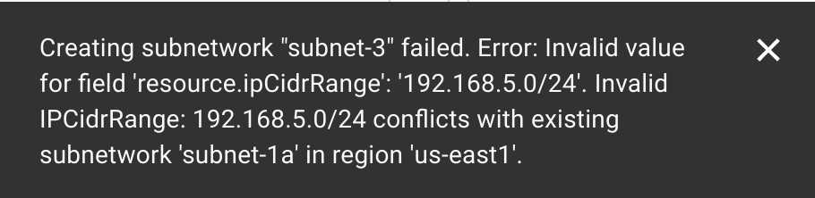

**Create VM instances**

For the purposes of exploring the Cloud Virtual Network, you will create five micro VMs in different locations in the network. You will not install any additional software on them. They will not be running any applications. You will just be using them to explore the connectivity across the topologies in the network.

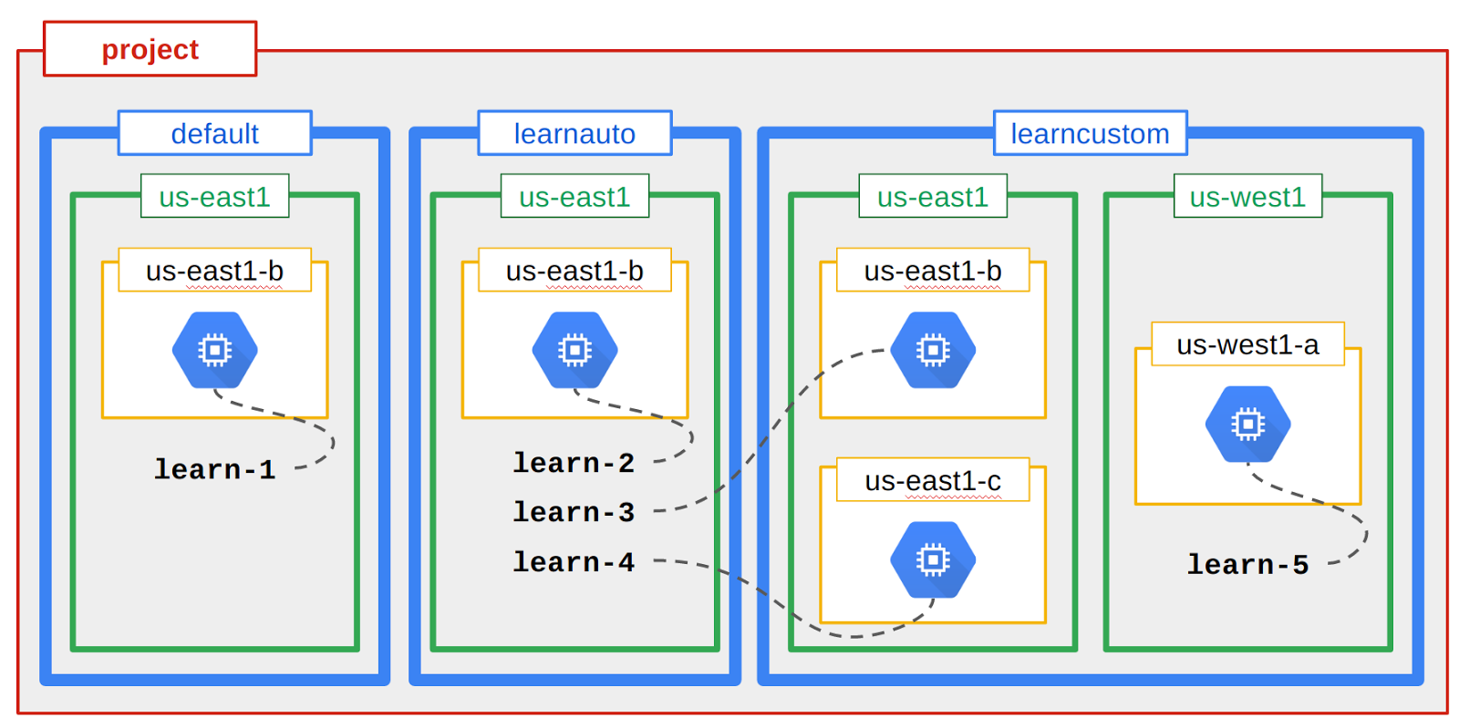

|  |  |  |  |
| --- | --- | --- | --- |
| **Name** | **Network** | **Region** | **Zone** |
| **learn-1** | default | us-east1 | us-east1-b |
| **learn-2** | learnauto | us-east1 | us-east1-b |
| **learn-3** | learncustom | us-east1 | us-east1-b |
| **learn-4** | learncustom | us-east1 | us-east1-c |
| **learn-5** | learncustom | us-west1 | us-west1-a |

**Step 1: Create the learn-1 VM**

Console: **Products and Services > Compute Engine > VM instances**

Click on [+ Create Instance]

|  |  |
| --- | --- |
| **Property** | **Value** |
| **Name**: | learn-1 |
| **Zone:** | us-east1-b |
| **Machine type:** | micro (1 shared vCPU) |

Click on the line that says **Management, disk, networking, SSH keys** to access the advanced options.

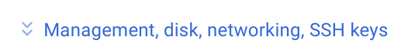

Click on the **Networking** tab.

|  |  |
| --- | --- |
| **Property** | **Value** |
| **Network**: | default |
| **Subnetwork:** | default |

Click the [Create] button.

**Step 2: Create the learn-2 VM**

Console: **Products and Services > Compute Engine > VM instances**

Click on **[+ Create Instance]**

|  |  |
| --- | --- |
| **Property** | **Value** |
| **Name**: | learn-2 |
| **Zone:** | us-east1-b |
| **Machine type:** | micro (1 shared vCPU) |

Click on the line that says **Management, disk, networking, SSH keys** to access the advanced options.



Click on the **Networking** tab.

|  |  |
| --- | --- |
| **Property** | **Value** |
| **Network**: | learnauto |
| **Subnetwork:** | learnauto |

Click the **[Create]** button.

**Step 3: Create the learn-3 VM**

Console: **Products and Services > Compute Engine > VM instances**

Click on **[+ Create Instance]**

|  |  |
| --- | --- |
| **Property** | **Value** |
| **Name**: | learn-3 |
| **Zone:** | us-east1-b |
| **Machine type:** | micro (1 shared vCPU) |

Click on the line that says **Management, disk, networking, SSH keys** to access the advanced options.



Click on the **Networking** tab.

|  |  |
| --- | --- |
| **Property** | **Value** |
| **Network**: | learncustom |
| **Subnetwork:** | subnet-1a |

Click the [Create] button.

**Step 4: Create the learn-4 VM**

Console: **Products and Services > Compute Engine > VM instances**

Click on **[+ Create Instance]**

|  |  |
| --- | --- |
| **Property** | **Value** |
| **Name**: | learn-4 |
| **Zone:** | us-east1-c |
| **Machine type:** | micro (1 shared vCPU) |

Click on the line that says **Management, disk, networking, SSH keys** to access the advanced options.



Click on the **Networking** tab.

|  |  |
| --- | --- |
| **Property** | **Value** |
| **Network**: | learncustom |
| **Subnetwork:** | subnet-1a |

Click the [Create] button.

**Step 5: Create the learn-5 VM**

Console: **Products and Services > Compute Engine > VM instances**

Click on **[+ Create Instance]**

|  |  |
| --- | --- |
| **Property** | **Value** |
| **Name**: | learn-5 |
| **Zone:** | us-west-1a |
| **Machine type:** | micro (1 shared vCPU) |

Click on the line that says **Management, disk, networking, SSH keys** to access the advanced options.



Click on the **Networking** tab.

|  |  |
| --- | --- |
| **Property** | **Value** |
| **Network**: | learncustom |
| **Subnetwork:** | subnet-2 |

Click the **[Create]** button.

**Step 6: Verify that all the test VMs are running**

Console: **Products and Services > Compute Engine > VM instances**

It should look something like this:

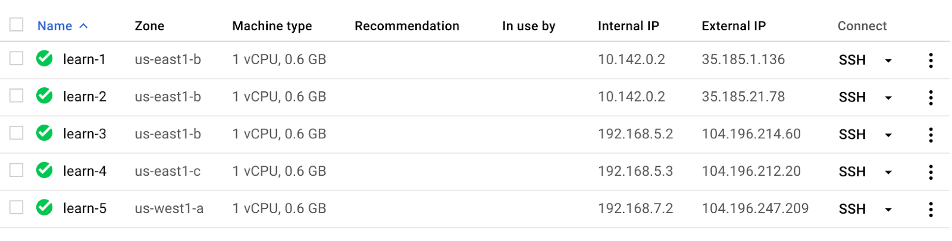

**Explore connectivity**

You will  to the VMs and use  to test connectivity between VMs. This will help you understand how the Cloud Virtual Network topology behaves.

One service of GCP is Cloud DNS. Cloud DNS provides IP translation. When you created the VMs, their addresses were automatically populated into Cloud DNS. For this reason, when you  to a VM you can use the  command with the symbolic name of the target VM, and it will be translated for you to the IP address.

You can break out of the  command at any time by pressing 

**Step 1: ping from learn-1**

Console: **Products and Services > Compute Engine > VM instances**

Click on the link to SSH to .

ping learn-1

Notice how DNS translates for you.

This should succeed.

Now try to reach learn-2.

ping learn-2

Can you explain why this fails?

It is because DNS is scoped to network. The VM  is not in the default network where  is located. So the symbolic name can't be translated.

Locate the internal IP address and the external IP address for .

Try to ping 's internal IP address.

ping <learn-2's internal IP>

Did this work?

In a few cases you may try to ping the internal IP of the other machine and it succeeds! Do you know why this would be the case?

Because ... the internal IP of the machine you are using could be the same as the internal IP of the VM in the other network. In this case, the ping would succeed because you are actually pinging *your own local VM's interface*, not the one on the the other VM in the other network.

When you create a new auto-type network, the IP ranges will be identical to the ranges in the default network. The first address in the range is always reserved for the gateway address. So it is actually likely that the first VM in a zone will have the same address as the first VM in the corresponding zone in another network.

If it didn't work...  is in the  network and  is in the  network. Even though both VMs are located in the same region,  and in the same zone, , they cannot communicate over internal IP.

Try to ping 's external IP address.

ping <learn-2's external IP>

This works.

**Step 2: traceroute from learn-1**

Verify that traceroute is working by tracing the route to a public website.

sudo traceroute cnn.com -I

Press to stop the command.

Did it work?

*Yes.*

Now use traceroute to find the path to learn-2's external IP.

sudo traceroute <learn-2's external IP> -I

How many hops was it from  to 's external IP?

*One.*

**Step 3: ping to learn-3**

You already know that  is in a different network from , so it's internal IP will not be reachable.

Try to ping 's external IP address.

ping <learn-3's external IP>

Press  to stop the command.

Why didn't this work? You were able to reach learn-2's external IP, why not learn-3's?

Recall that learn-2 is in an auto-type network, so firewall rules were automatically created that enabled ingress traffic to reach its external IP. However, learn-3 is in a custom-type network, and no firewall rules were established. You created a firewall rule to permit access.

Take another look at that firewall rule.

Console: **Products and Services > Networking > Firewall rules**

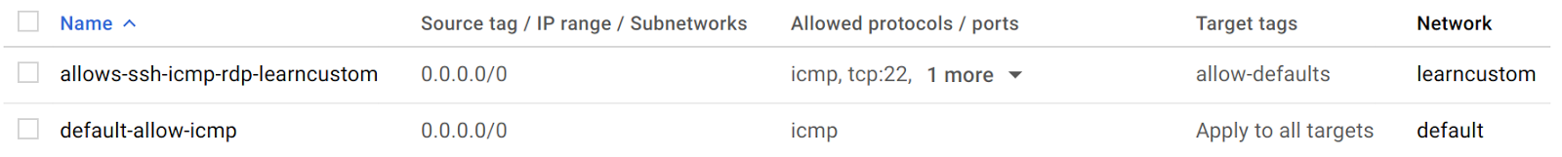

Notice that the default firewall rules were established to "Apply to all targets". You created the firewall rule with tighter security. It will only permit traffic to VMs that have the Target tag .

Locate the  VM in console.

Console: **Products and Services > Compute Engine > VM instances**

Click on . to access details about the VM.

Click on edit:9eb683ce0ed584f3.png

In the Tags section, add .

Click **[Save]** at the bottom of the page.

Return to the SSH terminal for  (or reconnect if needed).

Try again to ping 's external IP address.

ping <learn-3's external IP>

This time it should work.

**Edit the firewall rule**

**Step 1: ping to the other VMs**

Open an SSH terminal to .

Try the following. Can you explain all the behaviors?

ping learn-4

ping learn-5

sudo traceroute learn-5 -I

DNS translation is working for both  and  because all of these VMs are in the same network as , the  network.

Console: **Products and Services > Compute Engine > VM instances**

Try to SSH to .

The firewall rule for the  network only delivers traffic to VMs with the target tag .

**Step 2: Edit the firewall rule**

Console: Products and Services > Networking > Firewall rules

Click on the rule  to get to it's details.

Click on edit:9eb683ce0ed584f3.png

In the Target tags section, remove . It will now apply to all targets.

Click the **[Save]** button.

**Step 3: Try again**

Everything should work this time:

ping learn-4

ping learn-5

sudo traceroute learn-5 -I

SSH to .

**Convert an auto-type network to a custom -type network**

In this section, you convert an auto-type network to a custom-type network to gain more fine-grained control over the subnetworks.

A new policy for Network  is to be implemented. There will no longer be assets in  region. New projects will instead shift planned assets from  to a new subnetwork in  region to be named 

Implement the policy. To accomplish this you will delete the  subnetwork and create the new subnetwork in  to allow for the work that was originally planned for the  region.

**Step 1: Convert the network mode**

Console: **Products and Services > Networking > Networks**

Click on the **learnauto** network to view network details.

Notice that there is no option to select the subnetworks. You can only delete the entire network.

You won't be able to delete the subnetwork or create the new one because it's an auto-type network. You will have to convert it to a custom-type network to gain more control.

Return to the networks page.

Under **Mode**, you will see a pull-down menu that currently says "Auto subnetworks".

Click on edit:9eb683ce0ed584f3.png

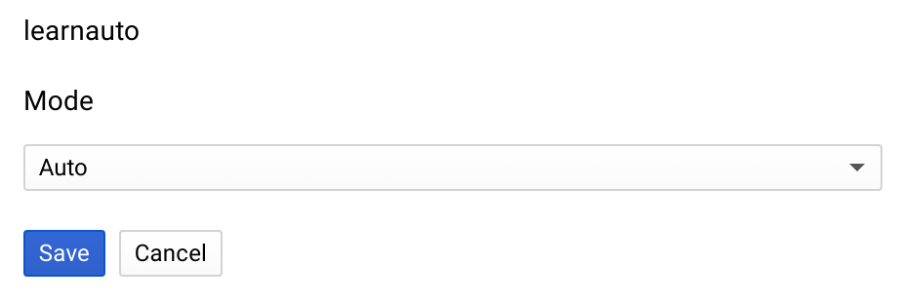

Use the pulldown menu to select "Custom".

Click the [Save] button.

**Step 2: Delete the subnetwork**

Click on the **learnauto** network to return to the network details. You should now be able to select and delete the  subnetwork.

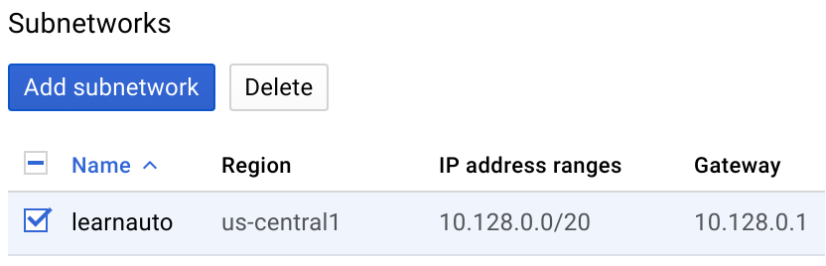

**Step 3: Create the new subnetwork**

create the new subnetwork in .

Reflecting the new tighter policies, the new subnetwork is CIDR /26. How many VMs can that support?

/26 = 64 addresses, minus broadcast, subnet, and gateway = 61 VMs.

Return to the networks page and click on the **learnauto** network to return to the network details.

|  |  |
| --- | --- |
| **Property** | **Value** |
| **Name**: | new-useast |
| **Region:** | us-east1 |
| **IP address range:** | 10.133.5.0/26 |

Click **[Add]**.

**Expand a subnetwork**

The projects in the  subnetwork have been a success, however, the original range of /26 was too restrictive. Expand the subnetwork to support at least 500 VMs.

**Step 1: Prepare to modify the address range**

Console: **Products and Services > Networking > Networks**

Click on the **learnauto** network to view network details.

Some features available in GCP are not yet supported in the console web user interface. This is one of those commands that must be entered manually into Cloud Shell.

Click on the Cloud Shell icon in the upper right part of the top menu bar to open Cloud Shell.

**Step 2: Increase the address range**

Enter the following command:

gcloud compute networks subnets \

expand-ip-range new-useast \

--prefix-length 24 \

--region us-east1

The IP range of subnetwork [new-useast] will be expanded from 10.133.5.0/26 to 10.133.5.0/24. This operation may take several minutes to complete and cannot be undone.

Do you want to continue (Y/n)? Y

**Step 3: Verify the change**

There is no refresh button on the network details page to see the result. Return to the networks page.

Click on Refresh until you see that the range has expanded.

**Delete resources that are no longer needed**

If you quit the lab now, the lab infrastructure would clean up and delete all the resources. However, in this section you will delete objects so that you can explore the dependent relationship in deleting. Objects must be deleted in a specific order.

Before you can delete networks and subnets, you must delete all VMs and firewall rules.

Console: **Products and Services > Compute Engine > VM instances**

**Step 1: Delete the VMs**

Select all the VMs and delete them.

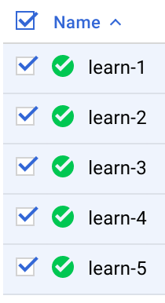

3fe844151441e09b.png

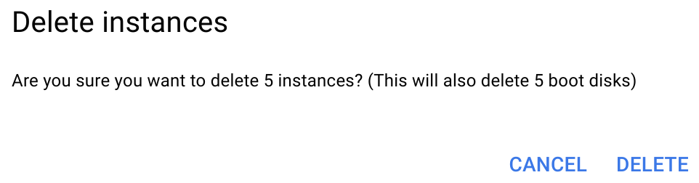

**Step 2: Delete the firewall rules you created**

Console: **Products and Services > Networking > Firewall rules**

Select all firewall rules that you created and delete them.

**Step 3: Networks**

Console: **Products and Services > Networking > Networks**

Click  to see Network details.

Delete the network.

Console: **Products and Services > Networking > Networks**

Click  to see Network details.

Delete the network.

Do **not** delete the Default network.

**Step 4: Review the delete project procedure**

You do not have the IAM role necessary to be able to delete the project. The following steps are to illustrate what the activity would look like if you could perform it.

However, if you were to delete the project, the process would look like this:

Console: **Products and Services > IAM & Admin > Settings**

Click on the Delete Project button:678bc6b314da107.png

The following message is displayed:

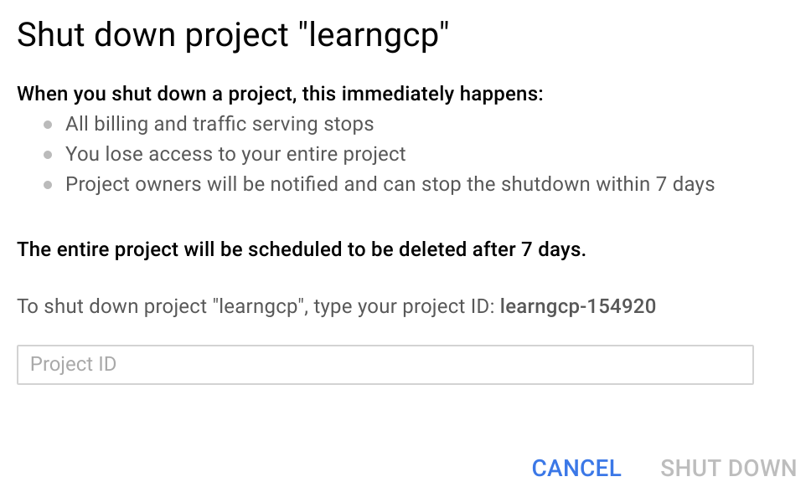

To shut down the project you would need to type in the Project ID and click **[SHUT DOWN]**

**Review**

In this lab you created networks and subnetwork of many different varieties, started VMs in each location, and then explored the network relationship between them.

©Google, Inc. or its affiliates. All rights reserved. Do not distribute.